**Login Page**

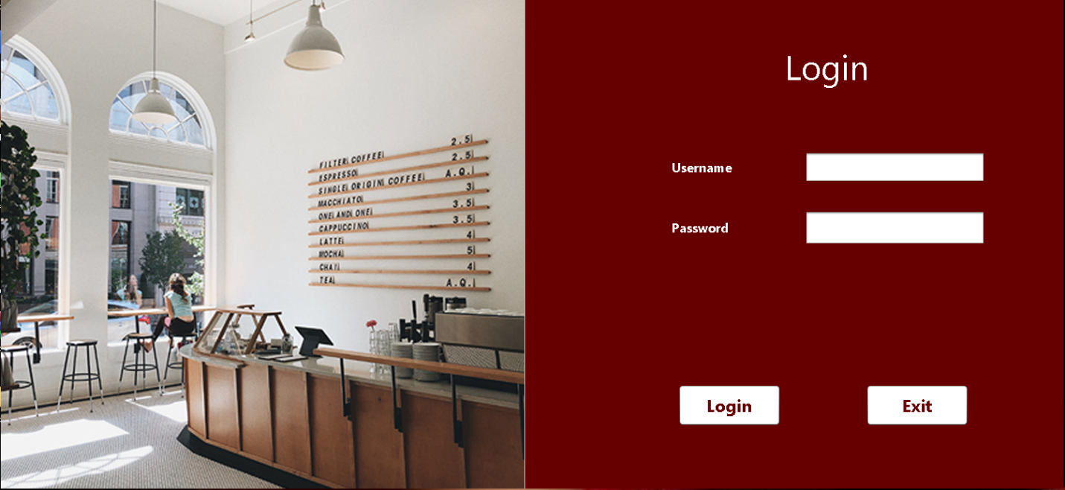

**Code**

1. **To Check if the** *username textbox*  **and**  *password textbox* **is empty or not.**

if(txt_lUsername.getText().isEmpty() || txt_lPassword.getText().isEmpty()){

JOptionPane.showMessageDialog(this, "Missing Entries");

} else {

1. **If entries are not missing then checks if** *username* **and** *password* **is available in the database white creating he connection to the database.**

Connection Con = null;

Statement St = null;

ResultSet Rs = null;

Con=(Connection) DriverManager.getConnection("jdbc:mysql://localhost:3306/cafe_managment_system","root","");

String query = "SELECT * FROM user WHERE username = ? AND password = ?";

PreparedStatement ps = Con.prepareStatement(query);

ps.setString(1, txt_lUsername.getText());

ps.setString(2, txt_lPassword.getText());

ResultSet rs = ps.executeQuery();

if(rs.next()){

dispose();

new Items().setVisible(true);

} else {

JOptionPane.showMessageDialog(this, "Invalid username or password");

}

**Item Management Page**

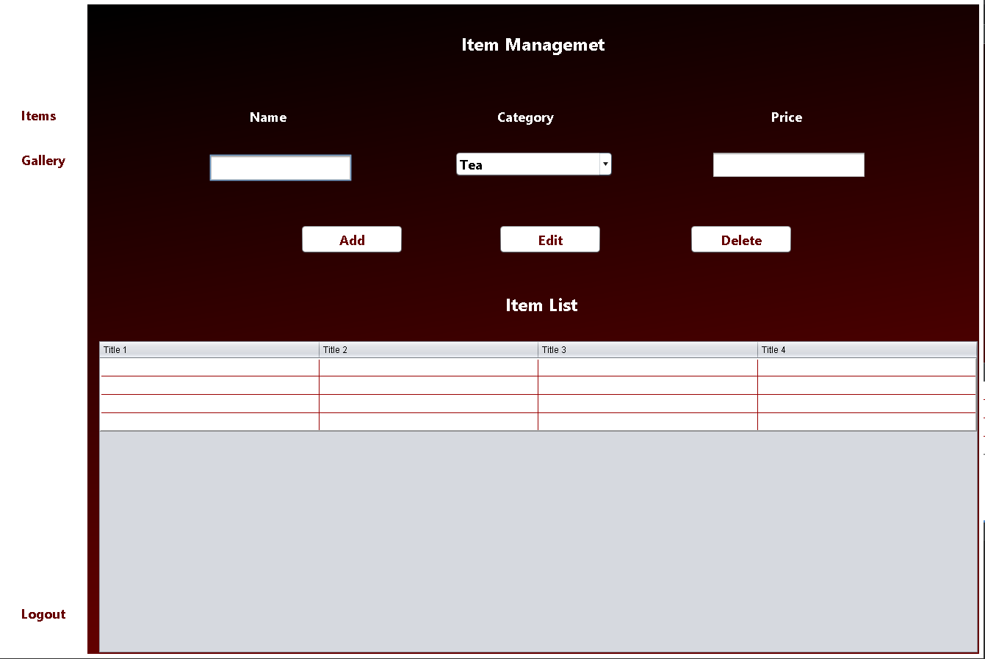

**Code**

1. **Delete button Code**

if(txt_name.getText().isEmpty()){

JOptionPane.showMessageDialog(this, "Enter Name to be Deleted");

}

else{

try{

Con = (Connection) DriverManager.getConnection("jdbc:mysql://localhost:3306/cafe_managment_system","root","");

String name = txt_name.getText();

String Query = "Delete from item_managment where name= '" + name + "'";

Statement Add = Con.createStatement();

Add.executeUpdate(Query);

Selects();

JOptionPane.showMessageDialog(this, "Item Deleted !");

}

catch(Exception e){

JOptionPane.showMessageDialog(this, e);

}

}

1. **Edit button Code**

if(txt_name.getText().isEmpty() || txt_price.getText().isEmpty()){

JOptionPane.showMessageDialog(this, "Missing Entries");

}

else{

try{

Con = (Connection) DriverManager.getConnection("jdbc:mysql://localhost:3306/cafe_managment_system","root","");

String Query = "UPDATE item_managment SET category='" + txt_cat.getSelectedItem().toString() + "', price='" + txt_price.getText() + "' WHERE name='" + txt_name.getText()+ "'";

Statement Add = Con.createStatement();

Add.executeUpdate(Query);

Selects();

JOptionPane.showMessageDialog(this, "Item Edited !");

}

catch(HeadlessException | SQLException e){

JOptionPane.showMessageDialog(this, e);

}

}

1. **Add button Code**

if(txt_name.getText().isEmpty() || txt_price.getText().isEmpty())

{

JOptionPane.showMessageDialog(this, "Missing Entries");

}

else{

try{

Con = (Connection) DriverManager.getConnection("jdbc:mysql://localhost:3306/cafe_managment_system","root","");

PreparedStatement add = Con.prepareStatement("insert into item_managment values(?,?,?)");

add.setString(1, txt_name.getText());

add.setString(2, txt_cat.getSelectedItem().toString());

add.setString(3, txt_price.getText());

int row = add.executeUpdate();

JOptionPane.showMessageDialog(this, "Item Successfully Added");

Con.close();

Selects();

}

catch(Exception e)

{

JOptionPane.showMessageDialog(this, e);

} }

1. **Table selection to textboxs**

public void Selects(){

try{

Con = (Connection) DriverManager.getConnection("jdbc:mysql://localhost:3306/cafe_managment_system","root","");

St = Con.createStatement();

Rs = St.executeQuery("select * from item_managment");

i_tble.setModel(DbUtils.resultSetToTableModel(Rs));

}

catch(Exception e){

JOptionPane.showMessageDialog(this, e);

}

}